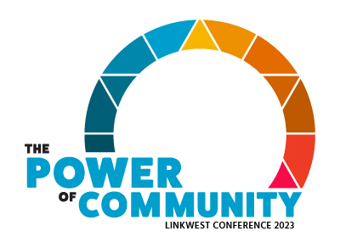

5&6 April 2023 | Mercure Perth on Irwin

Information Toolkit

Volunteer Scholarships
&
Travel / Accommodation Subsidies
(Rural / Remote)

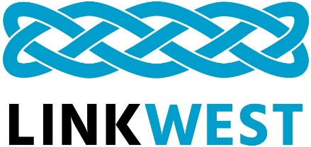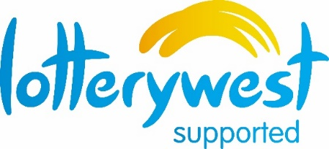

Linkwest acknowledges and appreciates the many creative ways Lotterywest contributes to our Neighbourhood and Community Resource Centres, and to the community sector in general.

About the Power of Community
This is Linkwest’s 22nd conference, and our formula of combining opportunities for professional development, networking and the sharing of best practice in an upbeat, fun and welcoming environment, not only works, but ensures this biennial event is a much-anticipated part of our calendar.
About the Volunteer Scholarships & Travel and Accommodation
Subsidies

Linkwest has secured funding from Lotterywest, which will allow us to offer incentives for staff and committee members of Linkwest Member Centres to attend The Power of Community conference, 5&6 April 2023.
Volunteer Scholarships (50 available)
- Scholarships include free attendance at The Power of Community conference including registration, conference materials and food. Please note: the Linkwest Awards Ceremony and Cocktail Evening is NOT included and will need to be paid for by the individual/Linkwest member Centre.
- Centres must be full financial members of Linkwest at the time of The Power of Community conference.
- Limited to one (1) volunteer per Linkwest Member Centre.
See page 3 of this package for more information and application instructions.

Travel and Accommodation Subsidies (limited availability)
- Financial support to help cover the travel and accommodation costs associated with attending the conference.
- For staff and volunteers of rural and remote Linkwest member Centres.
- Centres must be full financial members of Linkwest at the time of The Power of Community conference
See page 5 of this package for more information and subsidy limits.

Lotterywest / Linkwest Volunteer Scholarships

Acknowledge one of your volunteers for their contribution to your Centre by
nominating them for a Volunteer Scholarship

We have secured funding which will allow us to offer incentives for volunteers of Linkwest member Centres to attend The Power of Community conference. These Volunteer Scholarships are available for one volunteer per Linkwest Member Centre to a maximum of 50 scholarships.
- Scholarships include free attendance at The Power of Community conference including registration, conference materials and food. Please note: the Linkwest Awards Ceremony and Cocktail Evening is NOT included and will need to be paid for by the individual/Linkwest member Centre.
- Application forms for scholarships are included on page 4 of this pack.

All you have to do is:
- Identify an eligible volunteer from your Centre who would like to attend the conference.
- Complete the nomination form on the next page and email it to Linkwest.
- Encourage your volunteer to complete their registration through the Linkwest website, upon confirmation that the application was successful.

The successful applicants will be notified in plenty of time for them to make travel and other arrangements.

Criteria
- Centres must be full financial members of Linkwest at the time of The Power of Community conference
- The volunteer must attend both days of the conference and participate in workshops and plenary sessions on each day.

Please see next page for the
Volunteer Scholarship Nomination Form

Volunteer Scholarship Nomination Form

Member Centre:
Nominator’s name:
Name of nominated volunteer:
Volunteer’s email address:
- How long has the nominee been a volunteer at the member Centre?
- Has the nominee been or are they currently on the management committee?
Y N
If yes, how long have they served on this committee and in what position/s?
- Other volunteer position/s at the member Centre that the volunteer has held or currently holds:
- Can the volunteer commit to attending the full conference? Y N
If no, please provide details:
- Please state your reason/s for nominating this volunteer (max 200 words):

Nominator’s Signature Date: / /
Click on the image above to insert a scanned image of your signature
This form must be submitted by COB Wednesday 8 March 2023 to:

E. accounts@linkwest.asn.au

Lotterywest / Linkwest Travel and Accommodation Subsidies

- Each rural or remote Linkwest member Neighbourhood Centre and CRC can apply for a Travel and Accommodation Subsidy up to the maximum as outlined below.
General Details
- The Travel and Accommodation Subsidy provides financial support to rural and remote member Neighbourhood Centres and CRCs to help cover the costs associated with attending The Power of Community conference.
- The Travel and Accommodation Subsidy may be used in conjunction with a Volunteer Scholarship.
- Travel and Accommodation subsidies will be allocated on a first come, first served basis, until funding is exhausted.
- Member Centres sending a number of delegates to the conference and claiming travel expenses for private vehicles are encouraged to car-pool.
- Linkwest aims to process the subsidy applications and inform approved applicants promptly so travel arrangements can be booked as early as possible.
Payments
- Payment of the allocated Travel and Accommodation Subsidy for your member Centre will be on receipt of a completed Linkwest Travel and Accommodation Claim Form. Please ensure you attach copies of dated tax invoices for travel and accommodation costs.
- Claim forms will be sent when member Centres are informed that they have a Travel and Accommodation Subsidy approved, and will be paid AFTER confirmed conference attendance.
- No payments will be made to those who do not attend the conference.
Travel and Accommodation Subsidy limits
- Travel and accommodation amounts available are dependent upon the region.
- Accommodation is based on a maximum of $220 (excluding GST) per day per member Centre, to a maximum of three days.
Region | Maximum Accommodation Subsidy per Member Centre | Maximum Travel  Subsidy per Member Centre
Kimberley | $660 | $1,200
Pilbara | $660 | $750
Gascoyne | $660 | $400
Goldfields / Esperance | $660 | $500

Region | Maximum Accommodation Subsidy per Member Centre | Maximum Travel  Subsidy per Member Centre
Great Southern | $660 | $400
Midwest | $660 | $200
Wheatbelt | $660 | $150
Southwest | $660 | $150

Criteria
- Centres must be full financial members of Linkwest at the time of The Power of Community conference.
- Nominated applicant/s must be active in the organisation, i.e. management committee member, manager / coordinator, tutor, crèche volunteer, program planner, etc.
- Applicants must stay at the conference venue or find equivalent or lower priced accommodation.
- Applicants must attend the entire two (2) day conference.

If Travelling by Private Vehicle
Please be aware this is a travel SUBSIDY and that you will be reimbursed for fuel expenses only, NOT mileage.
- Reimbursement is limited to one vehicle per Centre and up to the limit for your region.
- Reimbursement is based upon litres of fuel used for kilometres (return) from your town of origin to the conference venue i.e. Mercure Perth on Irwin Street (or to your nearest airport / train station).
- Use Google maps to calculate the distance from your town of origin to the conference venue.
- The rate used is $1.70/litre @ 12L/100km (which is the highest rate of fuel consumption).

Procedure for Calculating Fuel Subsidy
- Use Google maps https://www.google.com.au/maps/search/maps to calculate the distance from your Centre (not from your home) to the Mercure in Perth.
- Use the following formula to calculate the estimated fuel cost:
(Distance x 2) x (12 litres/100) x $1.70 = $ claim
E.g. Albany to Perth - 415 km x 2 = 830 km (Return)
830 x 0.12 x 1.70 = $169.32
- Have an authorised representative from your member Centre sign your subsidy application.

Travel and Accommodation Subsidy Application Form

Please indicate the name and methods of travel to the conference for the applicant requesting the travel and accommodation subsidy (examples of modes of travel include plane, other public transport, private vehicle).
Organisation Details
Member Centre: |  | Contact Person:
Rural / Remote
Phone: | Email:
Applicant Details
Name: |  | Region:
Travel Mode*:
Estimated Cost of Travel: $
Estimated Cost of Accommodation: $
I will be attending the entire Conference: Yes No

* If travelling by private vehicle, please refer to the procedure under Travelling by Private Vehicle on page 6/7.

Statement
I certify that all information provided on this form is correct and that all persons being nominated and/or requesting a Lotterywest Travel and Accommodation Subsidy meet the criteria stated in the accompanying information package.

Signed: Date: / /
Click on the image above to insert a scanned image of your signature
This form must be signed by an authorised member Centre representative.

This form must be submitted COB Wednesday 8 March 2023 to:

E. accounts@linkwest.asn.au

